Diné College
Bachelors of Science in
Public Health

Student Handbook

Bachelors of Science in Public Health (B.S.P.H)
Student Admission and Registration Information

Welcome to the Diné College Public Health Program! The following is a list of instructions to gain admission into the program and for advising related to course registration.

For New Students Applying to the Program:

- Please go to the college website at www.dinecollege.edu and find the “Admissions” tab.
- Under “Admissions,” find and fill out the online application.
- The following is a list of documents required for admission to Diné College.
  - Admission Application: Online at www.dinecollege.edu
  - One time application fee of $20.00
  - Official Certificate of Indian Blood (for enrolled Native American Students)
  - Official high school transcript
  - Official college transcript(s) (for transfer students)
- Once you have submitted your application and required documents, your application will be reviewed and if you meet college guidelines, you will receive a letter of admission and your student ID.
Transfer Students: Once you have submitted your college transcripts with your admission materials to admissions, they will send your transcript to the registrar for evaluation. When the transcript has been evaluated for transfer credit, you will be referred to a Public Health appointed advisor (see #6 below).
- New students to Diné College will complete placement testing at this time.
- All students will be referred to a public health appointed advisor at their local Diné College site.
- At this time, you will contact your advisor to obtain a B.S.P.H degree checklist. Advisors will send a checklist to be filled out by you prior to the initial advising meeting. Please see attached example checklist.
- You will then email your advisor to set up a meeting for advisement.
- You will register for courses after meeting with your designated advisor.

For Continuing B.S.P.H Students:

Every semester, you will make an appointment with your advisor to discuss course registration.

Public Health B.S. Advisors:

The following is a list of advisors for the B.S.P.H Program:
- Tsaile/Chinle/Window Rock:
  - Calvin Dominguez; cdominguez@dinecollege.edu; 928-724-6861
  - Ed Curtis, ecurtis@dinecollege.edu; 928-724-6727
  - Public Health Faculty (see below)
- Shiprock/Crownpoint:

  - Public Health Faculty (see below)
- Tuba City:
  - Lisa Nuveyestewa; lnuvayestewa@dinecollege.edu
  - Public Health Faculty (see below)
- Public Health Faculty
  - Mark Bauer; mcbauer@dinecollege.edu, 505-368-3589
  - Carmella Kahn; ckahn@dinecollege.edu; 505-368-3583
  - Kathryn Hartzell; khartzell@dinecollege.edu; 505-368-3584​

B.S. in Public Health Course Descriptions

PUH 111 Introduction to Public Health (3)
This course introduces students to all aspects of the field of public health, focusing on health promotion and disease prevention goals designed to establish and maintain healthy communities. The 3 core functions and 10 essential services of public health, as well as reading and lecture materials are organized and presented within the contexts of the Diné educational philosophy. This course is intended to help students become both knowledgeable and culturally competent public health professionals in the Navajo Nation.
PUH 141 Nutrition for Health (3)
Prerequisite: MTH 096 and concurrent ENG 100B.
General concepts of nutrition applied to food choices that support health; cultural, psychological, and economic implications of food choices. Current concepts and controversies in human nutrition. Carbohydrate, protein, lipids, vitamins, and minerals in nutrition, and the relation of nutrition to health throughout the life cycle.
PUH 170 Medical Terminology (3)
Reading proficiency requirement or concurrent enrollment in ENG 101.

Basic tools are provided, such as root words, prefixes, and suffixes, for building an effective verbal and written biomedical vocabulary.
PUH 200 Principles of Health Education (3)
Prerequisite: Completion of ENG 075 or reading proficiency requirement; PUH 111 and HEE 110 or concurrent enrollment.
This course introduces students to the field of health education. It explores social and behavioral theories, and determinants of health behavior of individuals and groups. In their final project students must apply course concepts to design a prospective health education intervention. Course emphases are on health education methods and issues relevant to the Navajo Nation. Guest speakers involved in health education on the Navajo Nation may provide presentations. Content of the course will facilitate application of the principles of SNBH.
PUH 201 Principles of Environmental Public Health (3)
Prerequisite: Completion of ENG 075, PUH 111 or ENV 101 or another science class.
This course explores environmental health professionals’ roles in ensuring safe and healthy environments, including sanitation, food safety, and occupational safety, and air and water quality. Policies and activities of federal, state, local, and tribal entities are examined, with a focus on Navajo examples. Navajo cultural beliefs related to nature and the environment provide the foundation on which the course is structured.
PUH 241 Human Nutrition (3)
Prerequisite: CHM 130 or higher required
The principle of human nutrition as it relates to health issues is the primary focus of this course. Emphasis is placed on nutrients and how they affect the human body. The structure and function, digestion and absorption, and metabolism of carbohydrates, lipids, proteins, minerals, and vitamins are discussed. This course also examines energy, weight- management, nutritional requirements of different age groups, U.S. dietary trends, and guidelines for good nutrition and health.
PUH 270 Community Health Assessment and Planning (3)
Prerequisite: Completion of ENG 100B and PUH 111.
This is the first of two courses in which students examine assessment, planning, implementation, and evaluation in public health practice. The course focuses on assessment and planning as carried out in epidemiology, environmental public health, health education and promotion, and health services administration. It explores Navajo ways of knowing, defining, and thinking about health problems (Nitsáhákees) and the process of planning (Nahat’á) health intervention programs.
PUH 275 Health Services and Policy (3)
Prerequisite: Completion of PUH 111, ENG 101 or concurrent enrollment.
In this course, students are introduced to health services administration and the role of policy development in public health. The course covers national, state, local, and Navajo Nation health services, focusing on how they are organized and administered. U.S. public health services are compared with those on the Navajo Nation and other tribal communities. The course is taught in accordance with the Diné educational philosophy (primarily in the realm of Íiná).
PUH 280 Implementation and Evaluation of Public Health Interventions (3)
Prerequisite: Completion of PUH 111 and PUH 270. Completion or concurrent enrollment in ENG 101.
This is the second of two courses in which students examine assessment, planning, implementation, and evaluation in public health. The course focuses on implementation and evaluation as carried out in epidemiology, environmental health, health education and promotion, and health services administration. It is taught in accordance with the Diné educational philosophy (primarily in the realm of Íiná and Siihasin).
PUH 290 Public Health Research Methods (4)
Prerequisites: Knowledge of basic mathematical concepts (MTH 100), Biology (BIO 100 or above), and some computer literacy skills. ENG 101 and a Social and Behavioral Sciences course are recommended.
This research methods course covers basic concepts in public health, health promotion, and disease prevention, including its cultural aspects. The design and implementation of qualitative and quantitative research are covered, including hypothesis development, research design, development of research protocols, data analysis using computer software packages, and presentation of results.
PUH 297 Public Health Research Methods Practicum (3)
Students will apply their knowledge of experimental design, data collection and data analysis methods and techniques within the context of public health, health promotion and disease prevention programs or research settings, incorporating cultural aspects of disease prevention where appropriate. Presentation of findings to program stakeholders is also required.
PUH 300 Health and Human Disease (3)

Prerequisites: BIO 181, 201,202 or concurrent enrollment, PUH 111

An understanding of the biological and cultural basis of disease is critical to public health practice. Public health addresses biological, physical, chemical, behavioral, social, and cultural factors associated with individual and population health and, in recent years, health disparities over the life course. This course will focus on the fundamental principles relating to the etiology, nature, prevention, and control of both communicable and non-communicable diseases. Coursework will provide an overview of major diseases, their classification, causes, diagnosis, and treatment. Students will apply biological principles to public health research studies in order to understand the applied biology related to health and disease. Students will also learn indigenous etiologies of disease, screening, and treatment with a focus on traditional Navajo medicine. Students will learn to critically examine how we understand disease and to appreciate the multiple ways of diagnosing and treating disease in different public health settings.

PUH 345 Theories of Health Behavior (3)

Prerequisites: PSY 240, PUH 111

The purpose of the course is to provide students with an understanding of the application of the social and behavioral sciences to health. The course is designed to introduce students to some of the major theories, models, and conceptual frameworks that are frequently used to plan health promotion and disease prevention interventions that target behavior at the individual, interpersonal, community, and societal levels of intervention. This course will emphasize research on health behavior theory and American Indian and Alaska Native populations. Such research critiques Western based theory and highlights the role that traditional beliefs and practices play in understanding behavior and decision-making among indigenous groups.

PUH 350 Global Indigenous Health (3)
Prerequisites Completion of PUH 111 and Eng 101 or concurrent enrollment.

This course introduces the theories, perspectives, and methods of global health through an exploration of the health of indigenous groups around the world. Topics to be addressed include the global burden and distribution of disease and mortality, determinants of health status and health inequalities, the development of global health policies, and the implementation of global health interventions. Emphasis will be placed on indigenous notions of health and disease and global health systems unique to groups in different cultural settings.

PUH 355 American Indian Health Disparities (3)
Prerequisites: PUH 111 and ENG 102
This course will give students a beginning knowledge of the literature on health disparities and a solid understanding of some of the causes of these disparities. Students successfully completing the course will be able to describe and analyze the patterns of health disparity affecting various racial/ethnic, gender, income and sexual orientation groups, including health indicators, rates of disease, and health-related behaviors. They will also use theoretical strategies to understand/explain health disparities. Students will also describe and analyze the determinants of health disparities for American Indian groups, including social, political, and economic factors. This course will use examples of health disparities on the Navajo Nation as well as the many positive community-based strategies to address these disparities and decrease their likelihood in the future.

PUH 360 American Indian Maternal, Infant, Child and Sexual Health (3)
Prerequisites: PUH 111, and ENG 102
This course introduces students to the principles and practices of public health in the areas of maternal and child health and sexual health. Using the life course perspective, the course examines how infants, children, women and families develop in the context of biologic and social determinants of health, as they play out over a lifetime and across generations. The focus of this course will be American Indian/Alaska Native (AI/AN) women and their families including traditional notions of women, the body, pregnancy, childbirth, family, and children’s health. Selected current topics--such as asthma, adolescent pregnancy, infant mortality, and childhood obesity among AI/AN populations--are studied in depth and used to illustrate how problems are understood, their distribution in diverse populations, and the content and quality of programs required to address them. Throughout the course, special attention is given to the impact of poverty, poor access to health care, and racial inequalities on the health of AI/AN families, as well as to the strengths that individuals and communities among indigenous groups bring to the creation of solutions.

PUH 385 Mental Health Issues in Public Health (3)

Prerequisites: BIO 181, 201,202 or concurrent enrollment, PUH 111

An understanding of the biological and cultural basis of disease is critical to public health practice. Public health addresses biological, physical, chemical, behavioral, social, and cultural factors associated with individual and population health and, in recent years, health disparities over the life course. This course will focus on the fundamental principles relating to the etiology, nature, prevention, and control of both communicable and non-communicable diseases. Coursework will provide an overview of major diseases, their classification, causes, diagnosis, and treatment. Students will apply biological principles to public health research studies in order to understand the applied biology related to health and disease. Students will also learn indigenous etiologies of disease, screening, and treatment with a focus on traditional Navajo medicine. Students will learn to critically examine how we understand disease and to appreciate the multiple ways of diagnosing and treating disease in different public health settings.
PUH 391 Seminar in Public Health (3)
Prerequisite: PUH 111
This seminar course offers students the opportunity to explore current public health topics with an in-depth focus on issues affecting the Navajo Nation. It provides students the opportunity to interact with faculty and guest lecturers on topics currently making headlines and to explore how research from the past informs present day public health research and our understanding of what makes effective public health practice and policy. Topics covered will vary but may include such topics as current public health research on the Navajo Nation, public health issues for American Indian and Alaskan Natives, specific topics in environmental health on the Navajo Nation, American Indian/Alaskan Native healthcare delivery, and healthcare disparities and resilience.
PUH 395 Introduction to Epidemiology (3)
Prerequisite: MTH 110 or MTH 118 and PUH 111
A basic introduction to epidemiology is provided in this mathematics-based course. Students are guided in identifying relevant and appropriate public health data and information sources. A special focus is on relationships of risk factors and disease outcomes, with attention to the health priorities of the Navajo Nation. The course also introduces students to epidemiological research designs and measures, and ways in which they influence public health decision-making.
PUH 490: Advanced Public Health Research Methods (3)
Prerequisites: PUH 380 and 395 or concurrent enrollment

This course is the first part of the Senior Capstone Experience for the B.S degree in Public Health. Advanced concepts in public health, health promotion and disease prevention, and cultural aspects of disease prevention will be addressed. Advanced concepts of qualitative and quantitative research will be covered, including hypothesis development, research design, development of research protocols, analyses of data using computer software packages. Students will use the public health methods of assessment, planning, implementation, and evaluation to develop a public health prevention program, using the research skills to assess and evaluate the program that they themselves design.
PUH 497: Advanced Public Health Research Methods Practicum (4)
Prerequisites: PUH 490

This course is the fieldwork component of the Senior Capstone Experience for the B.S. degree in Public Health. This course will assist the student in the application of data analysis methods & techniques utilizing concepts of public health, health promotion & disease prevention, and incorporating cultural aspects of disease prevention where appropriate. The student should apply their basic knowledge of experimental design & statistical analysis in either a quantitative and/or qualitative research setting, or in a health agency setting. Students will create an independent research project presentation, portfolio, and resume as a final project for the B.S degree in Public Health.
PUH 498 Indigenous Health Research Methodologies (4)
Prerequisites: NIS 111, NIS 221, PUH 111, PUH 395 (Epi), PUH 370,380 or concurrent enrollment.

The course will acquaint students with indigenous research concepts and issues. We will introduce basic concepts in qualitative and quantitative research designs and their application to research in Native communities, with illustrations from ongoing research studies to provide practical examples of a variety of research designs and their application. We will introduce research methods that are informed by Indigenous ways of producing and sharing knowledge, ethical considerations, collaborative research design with Indigenous communities and peoples, the sharing of research materials and outcomes, multi-vocal authorship, learning to integrate responsibilities as a researcher, and the respect for cultural property rights and ownership. Such methods will prepare students to develop a better understanding of, and professional capacity for effectively and collaboratively working with Indigenous communities, to deconstruct a long history of “colonizing” research, and to build reciprocal, respectful, and mutually beneficial relationships between researchers and Indigenous communities. Participants will be given an opportunity to develop research questions and study designs to obtain practical experience with the principles taught during the course.

Meet the Public Health Faculty

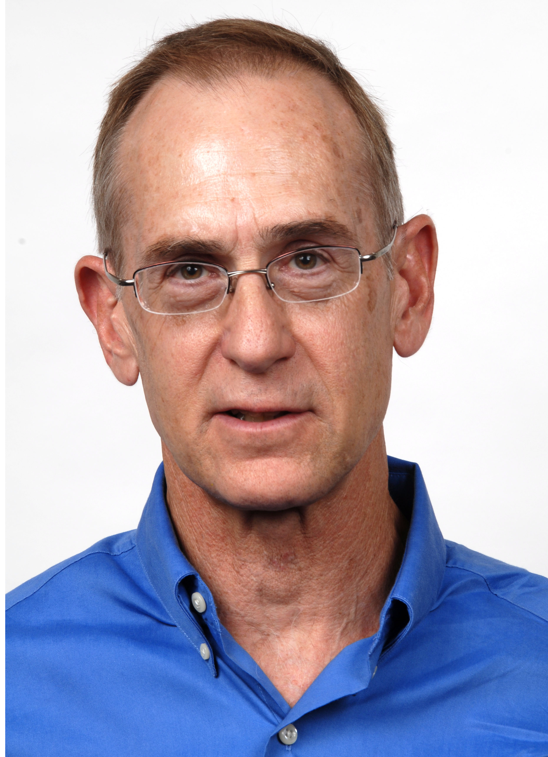
Mark Bauer, PhD

My ability to direct research efforts on the Navajo Nation has been established through over 35 years as a member of the Diné College faculty teaching in the Division of Science and Math. I developed a highly successful Summer Research Enhancement Program (SREP) to teach public health research methods to undergraduate Navajo students and support their participation in internships in a variety of programs serving Navajo communities in areas of diabetes and cancer prevention, and promotion of wellness in general. Through SREP, I have developed trusted partnerships with tribal and Indian Health Service programs and have been a leader in expanding opportunities for Navajo students through course and program development in collaboration with research intensive institutions. Currently, I serve on the Navajo Nation Human Research Review Board and several Navajo Division of Health-IHS-Diné College working committees. As an NIH funding awardee, I have conducted health research projects in areas of diabetes management and cancer screening. As a USDA funding awardee, I have focused on research in nutrition and availability and affordability of health foods in trading posts and convenience stores on the reservation.

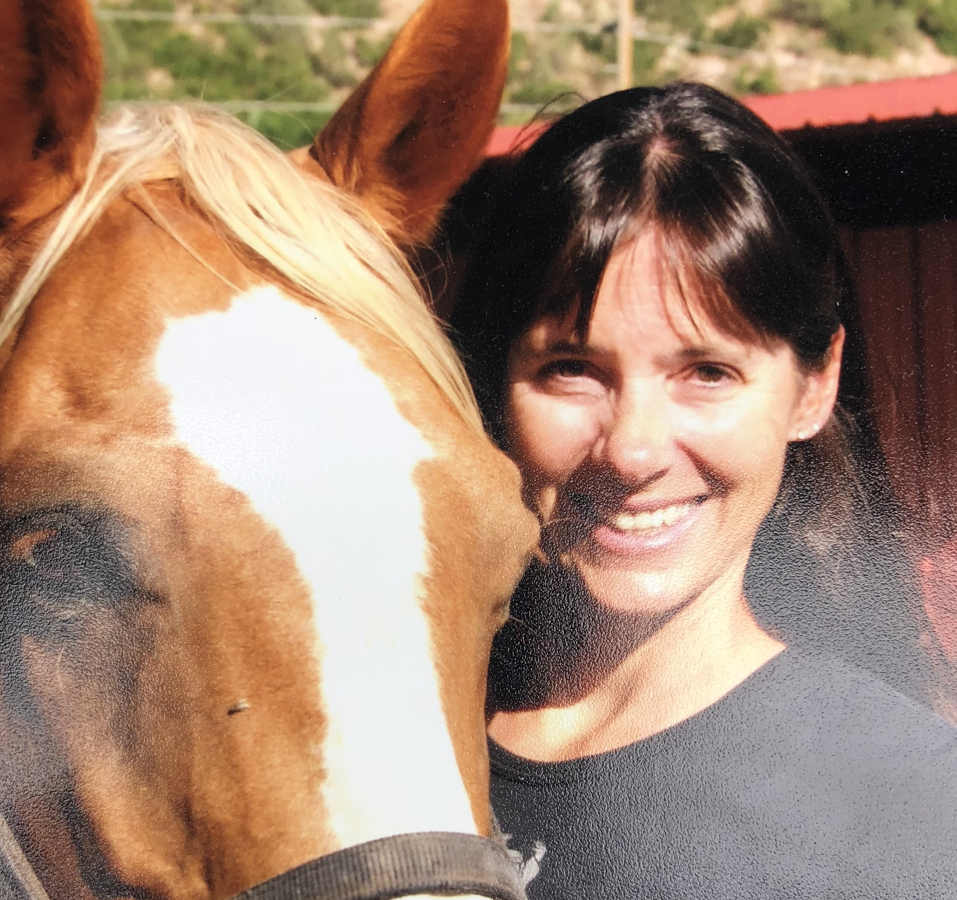
Kathryn Hartzell, M.A., M.A.T, M.P.H

My experience with community and world health, anthropology, and education has shaped my passion for creating public health education that is community-based and that honors culture as a significant determinant of health and wellness. I have worked in medical anthropology, focusing on issues of women’s health and on maternal and child mortality in South Asia. My public health work and research has focused on maternal/infant health, women’s reproductive health, and health education. I have been a teacher for twenty-five years, teaching students from kindergarten to college. Since being at Diné College, I have helped develop the competencies, curriculum, instruction, and assessment for the Bachelors of Science in Public Health. I am a co-investigator on the Navajo NARCH partnership grant, the REACH for Healthy Navajo Communities grant, and the Yéego Healthy Eating and Gardening Study. I also mentor and direct students doing independent research in the advanced Summer Research Enhancement Program (SREP II). I am happiest when I am in the classroom working and sharing ideas with students.

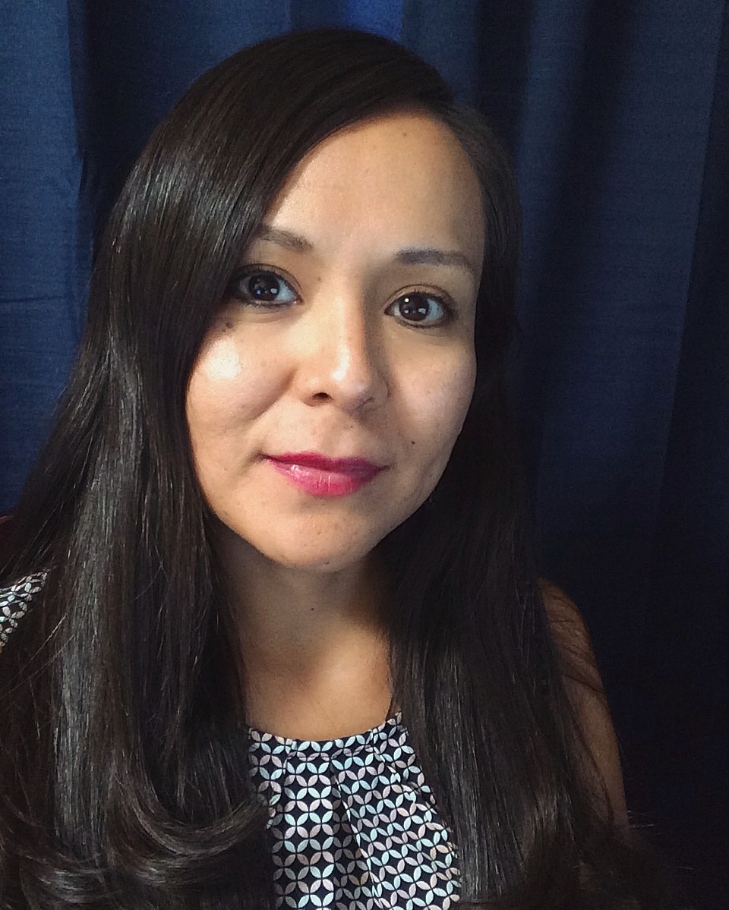
Carmella Kahn, DrPH, MPH, (Diné)
For over 10 years, I have worked on community based participatory research projects with American Indian (AI) communities. My expertise includes curriculum development, project management, and program design and implementation. I have worked as a Research Associate for the Northern Arizona University Center for Health Equity Research. Currently, I am a public health faculty member at Diné College and I am assisting in the development of the Indigenous Summer Enhancement Program in Public Health for high school students on the Navajo Nation. I was the principal investigator of a gardening project for urban AI youth, a research assistant for AI youth and family wellness programs in Tucson, AZ, and a research assistant for an elders’ resilience project in collaboration with the Tucson Indian Center. For the past three years, I have also assisted in developing undergraduate public health curriculum and co-teaching classes for the Summer Research Enhancement Program (SREP) at Diné College.

Jobs in Public Health

The following is a list of job possibilities in the field of public health.

Health Educator
Community Health Workers/Representatives
Occupational Health and Safety Specialists
Medical and Health Services Managers
Clinical Research Coordinators
Environmental Scientist
Healthcare Administrator
Biostatistician
Epidemiologist
Program Support Consultant
Program Evaluator
Program Supervisor
Education Program Coordinator
Professional Research Assistant
Health Data Analyst
Data Coordinator
Health Coach
Community Outreach Specialist
Prevention Assistant
Neighborhood/Town Wellness Coordinator
Internship Advisor/Coordinator
Infection Preventionist
Community Services Coordinator

This degree is also a good degree for anyone interested in healthcare and other forms of clinical care- though it does not offer all of the pre-requisites for nursing or medicine.

